EXPERIMENT 1

Aim: To Create, Alter, Drop, Rename, Truncate using Data Definition Language (DDL) statements.
Description: Data Definition Language (DDL) statements are used to define the database structure or schema.
DDL Commands: Create, Alter, Drop, Rename, Truncate
CREATE - to create objects in the database
ALTER - alters the structure of the database
DROP - delete objects from the database
TRUNCATE - remove all records from a table, including all spaces allocated for the records are removed
RENAME - rename an object

SYNTAX:
CREATE TABLE
CREATE TABLE table_name ( column_name1 data_type, column_name2 data_type, column_name3 data_type, .... );

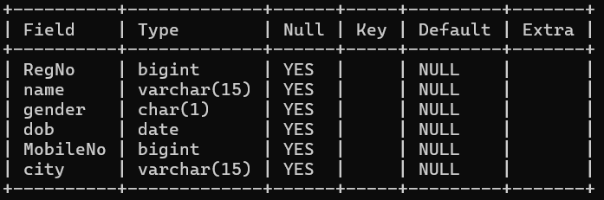

ALTER A TABLE
To add a column in a table
ALTER TABLE table_name
ADD column_namedatatype;
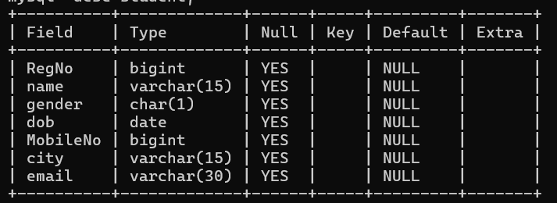
To delete a column in a table
ALTER TABLE table_name
DROP COLUMN column_name;
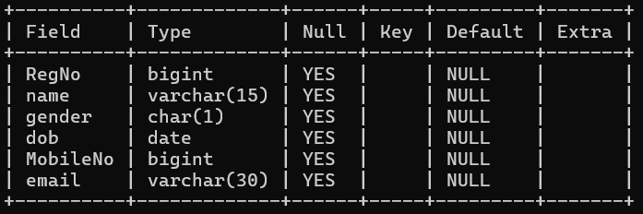

DROP TABLE
DROP TABLE table_name;
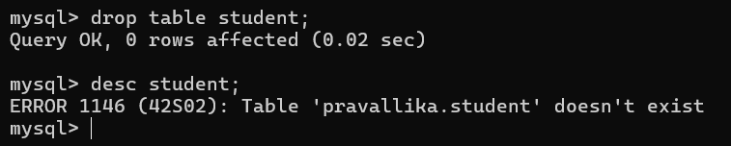
TRUNCATE TABLE
TRUNCATE TABLE table_name;
